Fossils (Grades 2-5)

Tennessee State Standards Covered
0207.5.2 Infer the characteristics needed by an organism to survive in a particular environment
0207.5.3 Observe fossils or pictures of fossils and make inferences about the organisms from which they originated
0207.5.4 Compare pictures of fossils with animals or plants that are living today
0307.5.2 Investigate the connection between an organism’s characteristics and its ability to survive in a specific environment
GLE 0407.5.2 Describe how environmental changes caused the extinction of various plant and animal species
0407.5.4 Gather fossil information to draw conclusions about organisms that exist today
GLE 0507.5.2 Analyze fossils to demonstrate the connection between organisms and environments that existed in the past and those that currently exist
0507.5.1 Classify animals according to their physical characteristics
0507.5.2 Design a model to illustrate how an animal’s physical characteristics enable it to survive in a particular environment
0507.5.3 Identify the processes associated with fossil formation
0507.5.4 Use fossil evidence to describe an environment from the past
0507.5.5 Use fossils to match a previously existing organism with one that exists today

ACTIVITY 2:
Materials
For each student:
- Student fossils
- Analysis of Fossil Samples Chart (optional)
- Student Science Notebooks

For class:
- Fossil PowerPoint
- Geologic Cross Section poster/image
- Book Fossils Tell of Long Ago by Aliki
- Brachiopod and Trilobite fossils

Preparations
- Set up PowerPoint

Procedures
1. Summarize activity 1

2. Show the PowerPoint on fossils making the following points:
- It takes special conditions to make a fossil.
- Fossils give us clues to life and the environment of long ago.
- Fossils help us to understand plant and animal species over time.

3. Arrange the class in a big circle on the floor. Show the Brachiopod fossil. Ask
questions such as:
• What might you find today that looks like this organism? (clam)
• What environment did it live in? (in the water, perhaps the ocean)
• Why do you think that? (clams live in the water, they have two hard shells,
they have no wings or feet)

4. Show the trilobite fossil that no longer exists today.
• What might you find today that looks like this organism? (We don’t see this organism today but it is related to the arthropods such as pill bugs, sow bugs, lobster.)
• What is the term we use to describe organisms that are no longer living? (EXTINCT)
• What environment did this organism live in? (shallow ocean water)
• Why do you think that? (same habitat the lobster lives in)

5. Using their fossil descriptions from Part One, have students find “their” fossil
from the fossil set.

6. Students read the information on the label of the fossil bag. Ask students to stand. Engage them in a ‘sorting exercise’ using the following categories:
- Plant or animal
- Extinct organism or not extinct organism
- Lived on land or lived in the water

7. Students should return to their seats. An Analysis of Fossil Samples Chart (see below) could be created by asking students to discuss each of the fossils. The chart can be done as a group using an overhead. Students can record the data using their own chart attached to their science notebook.

8. Students should put their fossil back into its corresponding bag. Pick up fossils.

Analysis of Fossil Samples

Fossil | Plant | Animal | Extinct Not  Extinct |  | Land | Water
Ammonite |  | X | X |  |  | X
Brachiopod |  | X |  | X |  | X
Crinoid Stem |  | X |  | X* |  | X
Dinosaur Bone |  | X | X |  | X
Dinosaur Egg Shell |  | X | X |  | X
Echinoid |  | X |  | X |  | X
Nautiloid |  | X |  | X* |  | X
Oyster |  | X |  | X |  | X
Petrified Wood | X |  |  | X | X
Rugose Coral |  | X | X* |  |  | X
Shark Tooth |  | X |  | X |  | X
Trilobite |  | X | X |  |  | X
*Students should use the text found on the Fossil Cards to cite evidence for extinct and not extinct.

 | Fossil Type |  | Status |  | Habitat
Fossil | Plant | Animal | Extinct | Not Extinct | Land | Water
Bryozoan |  | X |  | X |  | X
Brachiopod |  | X |  | X |  | X
Trilobite |  | X | X |  |  | X
Cephalopod – Nautiloid |  | X |  | X |  | X
Coral |  | X |  | X |  | X
Gastropod |  | X |  | X |  | X
Crinoid |  | X |  | X |  | X
Bivalve |  | X |  | X |  | X
Shark tooth |  | X |  | X |  | X
Sponge |  | X |  | X |  | X
*Students should be able to use booklet in fossil kit to get all of this information

9. Using the picture of the geologic cross section (in folder), remind students that a Paleontologist is a scientist who studies fossils. They study places on the earth where fossils have been exposed through erosion, excavation, or earthquakes.

Key for Layers in Geologic Cross Section Poster—top to bottom
- Visible hills of post-basalt sediment
- Gingko Flow flood basalt
- Petrified wood in bottom of Gingko Flow Vantage sandstone of fluvial sand Museum Flow of basalt
- Sedimentary interbed
- Rocky Coulee of flood basalt
- Flood basalt
10. Discuss how a fossil could be found in different layers, such as a fish that lived in the ocean at one layer and a leaf from a tree in another layer. You might then find a dinosaur skeleton at another layer.
- How might this happen? (the environments change over time – each layer represents a point in time when something was buried)

11. End the lesson by reading: Fossils Tell of Long Ago by Aliki. Before you read the book, please be aware of the following misconceptions that should be addressed.

MISCONCEPTION #1

The fish within a fish on page 10 – 11 shows a little fish inside the larger fish. This little fish would also be fossilized bones and not a whole fish. It’s soft tissue would probably have decayed as well.

TEACHABLE MOMENT:

After reading this page, show the sequence of pictures and ask students, “Is there a problem with these pictures?” Foster some brainstorming and discussion about the misrepresentations as well as some reasoning as to why the author decided to show the little fish as if it was just eaten. Take this opportunity to discuss how important it is to read books with a “critical eye” for accuracy.

MISCONCEPTION #2

Making a handprint fossil on page 28 – 29 misrepresents the amount of time a fossil might take to form. In fact, fossils take millions of years
to form. Students may get the impression that their handprint is a real fossil.

TEACHABLE MOMENT:

After reading these pages, discuss why this is a model of a fossil and
not truly a fossil. Understanding models as a representation of an actual occurrence is valuable but students need to understand that models are not the real thing.

EALRs for Reading
EALR 1 | The student understands and uses different skills and strategies to read
1.2 | Uses vocabulary (word meaning) strategies to comprehend text
EALR 2 | The student understands the meaning of what they have read
2.1 | Demonstrate evidence of reading comprehension
2.2 | Understand and apply knowledge of text components to comprehend text
2.3 | Expand comprehension by analyzing, interpreting, and synthesizing information and ideas in literary and informational text
2.4 | Think critically and analyze author’s use of language, style, purpose, and perspecitive in informational and literary text
EALR 3 | The student reads different materials for a variety of purposes
3.1 | Read to learn new information
3.4 | Read for literary/narrative experience in a variety of genres

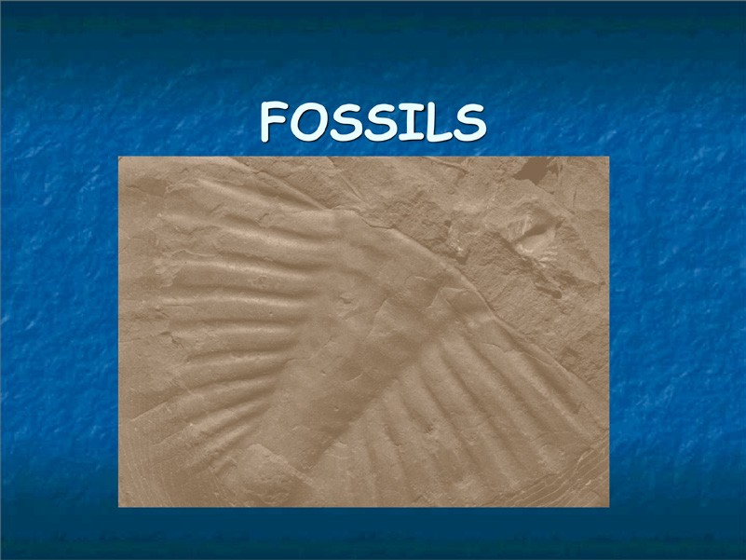

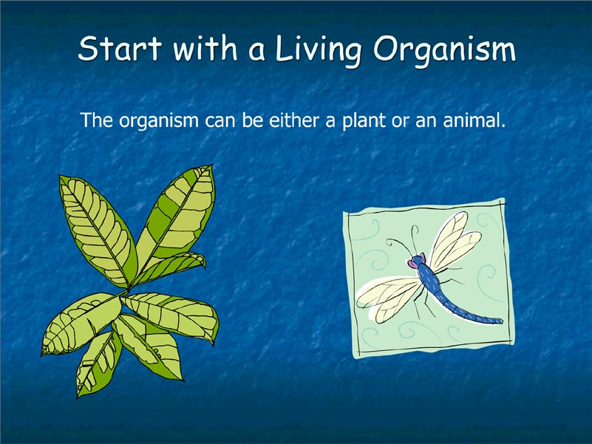

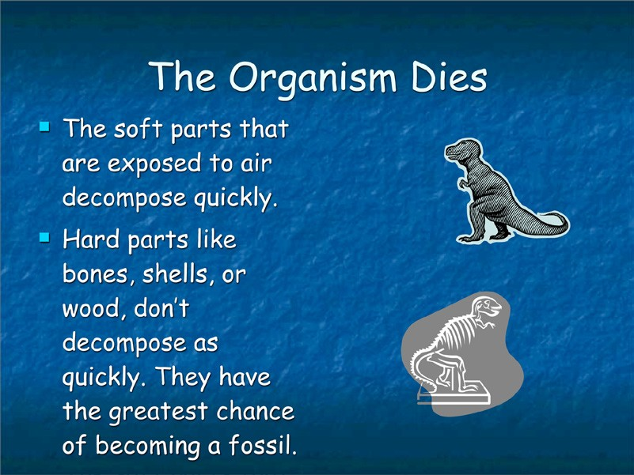
Ask children what it means to decompose. (to breakdown, to rot, to disintegrate)

You might have your students feel their own hand for soft parts (skin, tendons, muscles) and hard parts (bones and joints.)

Some fossil beds contain soft bodied fossils. To find out more, do a web
search for Burgess Shale.

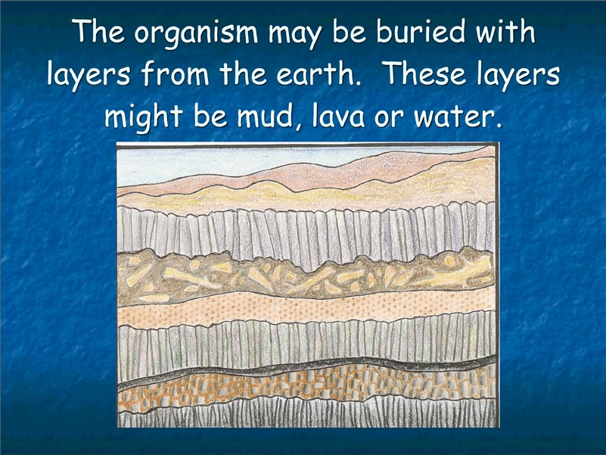
When an organism is covered, it is protected from weather damage, rotting or decay, and from scavengers who might eat the
dead organism.
Layers shown from top down:

• Top two layers are sediment
• Basalt
• Fossil layer—sedimentary
• Sandstone
• Basalt
• Sedimentary
• Basalt
• Basalt

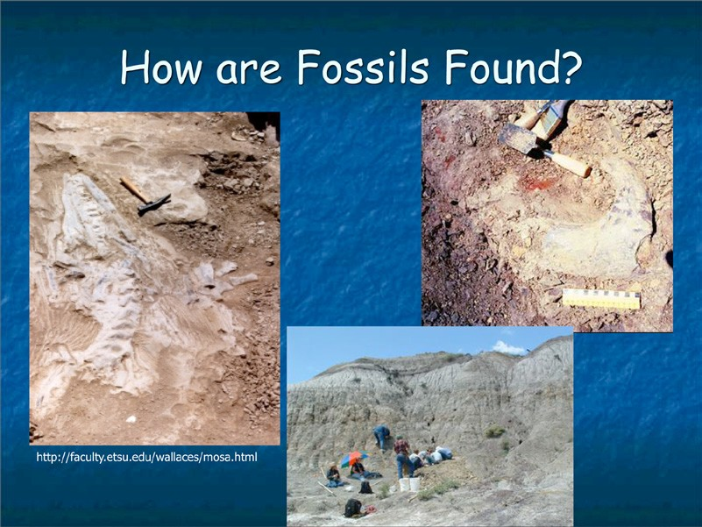
Sometimes fossils are found on the surface of the earth. They become exposed by:

• Weathering
• Erosion
• Earthquakes
• The activity of humans

Once fossils are found, scientists often dig in the same area to find other
fossils.

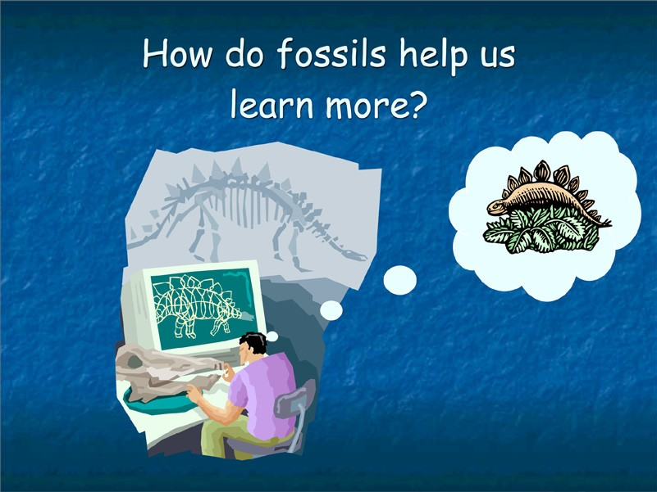
Point out that the scientist in the picture is making observations of an animal skull. From observations the scientist makes inferences about the environment and life of long ago.

Observation: The skill of recognizing facts or occurrences in the natural world.

Inference: The skill of arriving at a decision or conclusion (best guess) after examining all of the known facts and information.

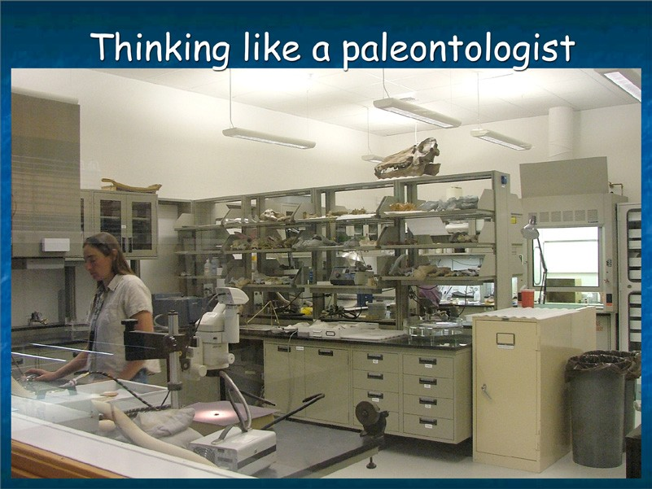
A paleontologist is a scientist who studies fossils. Paleontologists and many other scientist use inference—this is not what they actually observe, but what they think about their observations.

This picture shows a scientist working in a lab. What tools is the scientist using? (microscopes, lights, magnifying glasses, small hand tools.)

What fossils do they see in the lab? (skull on shelf, bones on table, specimens on shelves.)

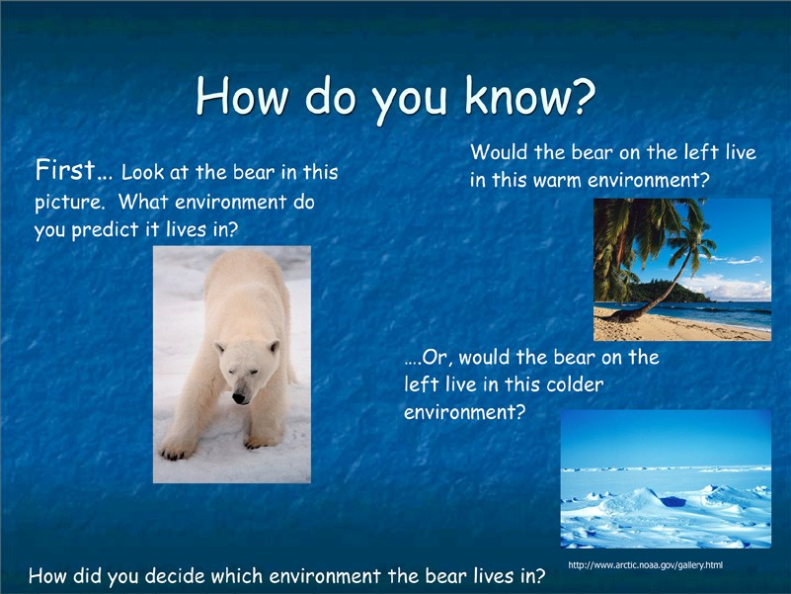
Students need to make observations about this polar bear. Ask them to make an inference about the environment in which the polar bear lives.

Possible observations of why they chose a certain environment:

• Thick white fur
• Standing on snow

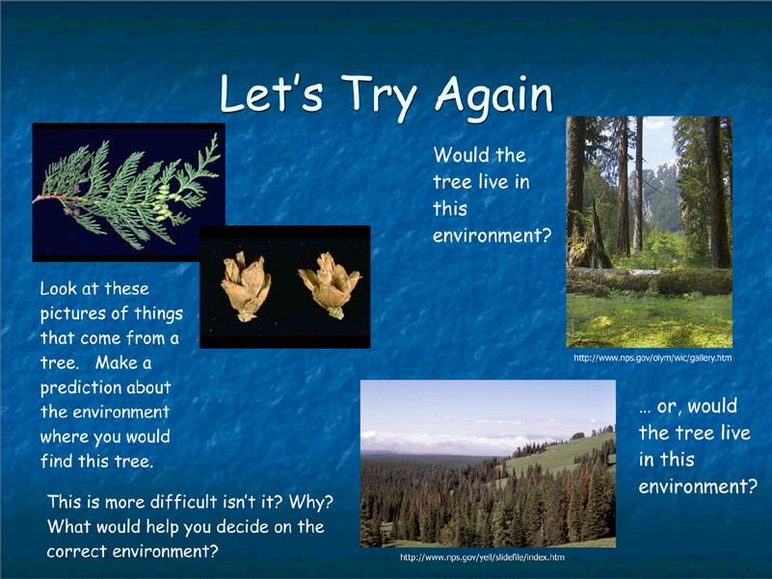
Students are not expected to know or learn the answers to these questions. The emphasis is on that to answer the questions, you need more information about the plants and the environment where the plants are found. Scientists who study fossils use their knowledge about current and extinct plants and animals to make predictions about new discoveries.

Questions a scientist might ask:

• What do I already know about similar plants or animals?
• Where can I go to find out information?
• What else has been discovered in this area?

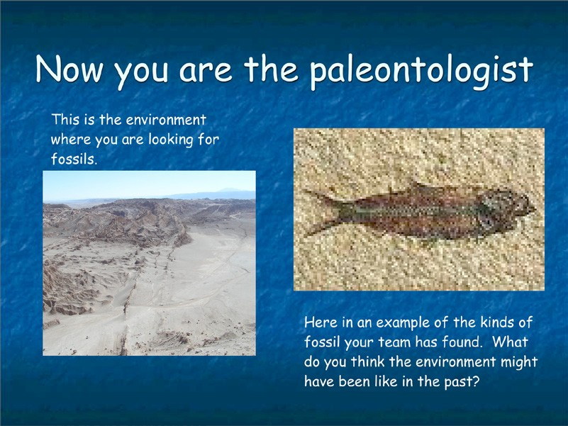
The fossil, that of a fish, lived in a lake or ocean certainly not the sand dunes where it was found by scientists. This should tell the students that the area must have been covered by water in the past.

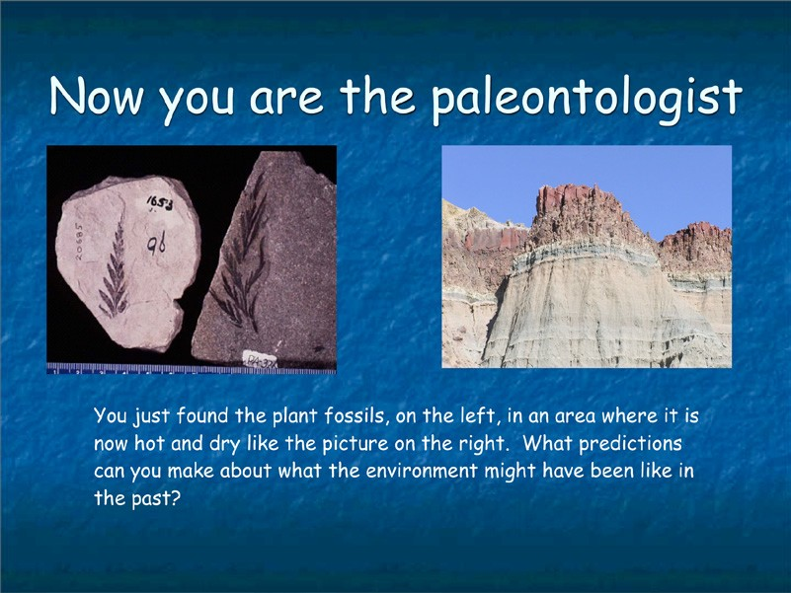
The plant (fern) fossils would indicate a moist, shady environment, certainly not the desert where it was found.

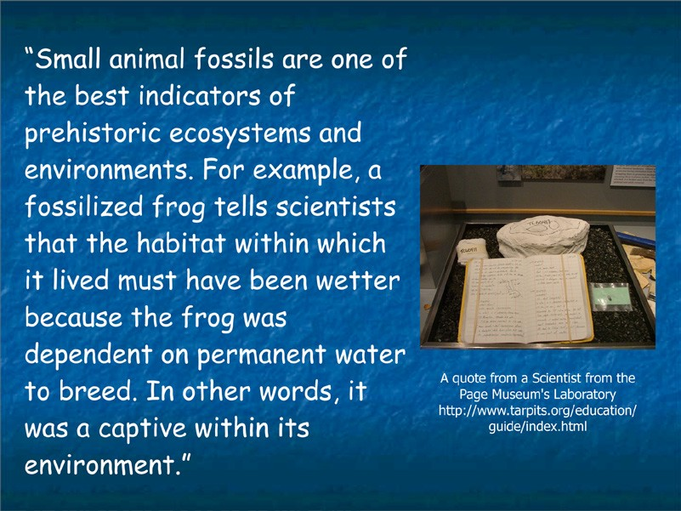
This page is from a Paleontologist’s notebook.

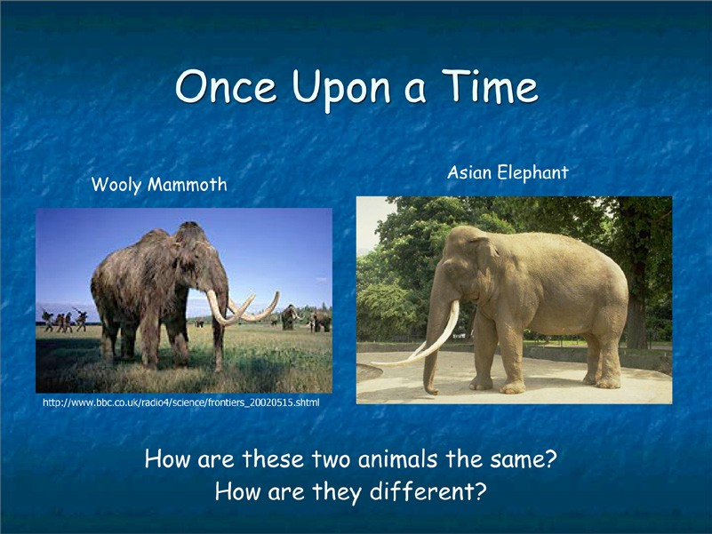
Have students compare the woolly mammoth and the Asian elephant. How are they alike and how do they differ. As a group you might want to create a Box & T-Chart on the overhead, flipchart or whiteboard. Remind your students that the Box & T-Chart is based upon observations only not inferences. Example of Box & T-Chart below.

Compare and Contrast with a Box and T-Chart

Similarities Large white tusks
Lump on head
Long, flexible trunks that touch the ground
Big body shape

 | Woolly Mammoth | Asian Elephant
Differences | Long Hair  More curved tusks Large hump on back Larger ear flaps | Short Hair  Less curved tusks No hump on back Smaller ear flaps

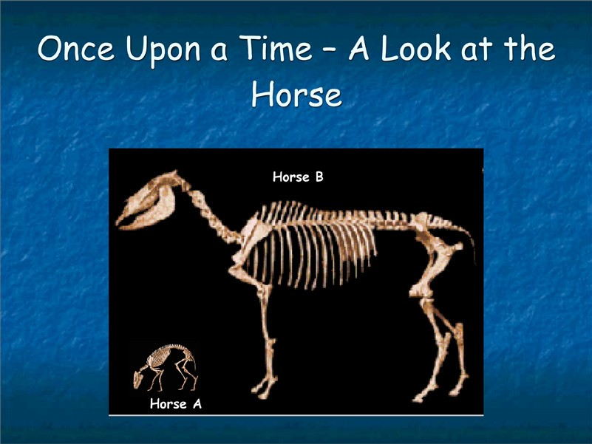
Horse A
Hyracotherium – 55 million years ago (Eocene Epoch)

This small dog-sized animal represents the oldest known horse. It had a primitive short face, with eye sockets in the middle and a short diastema (the space between the front teeth and the cheek teeth). Although it has low-crowned teeth, we see the beginnings of the characteristic horse-like
ridges on the molars. Hyracotherium is better known as “eohippus”—which means “the dawn horse.” The name also refers to the fact that it lived during the Eocene.

Horse B
Equus – 5 million years (Pliocene to Present)

Equus is the only surviving genus in the once diverse family of horses. Domesticated about 3,000 years ago, the horse had a profound impact on human history in areas such as migration, farming, warfare, sport,
communication, and travel. Species of Equus lived from 5 million years ago until the present. Living species include horses, asses, and zebras. Fossils of Equus are found on every continent except Australia and Antarctica.

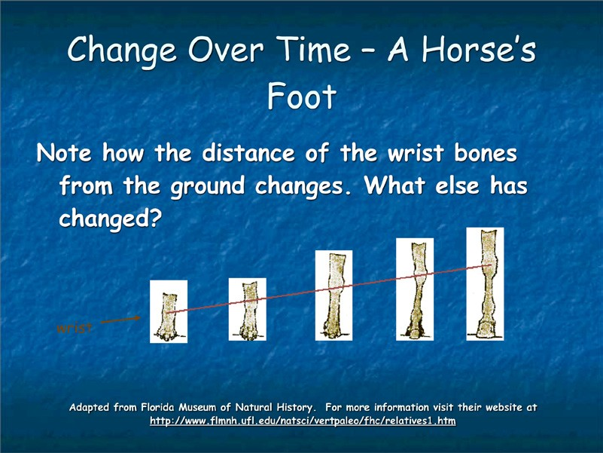
What to look for:

• Total length of foot
• Number of toes making up the foot
• The size of the hoof covering the foot

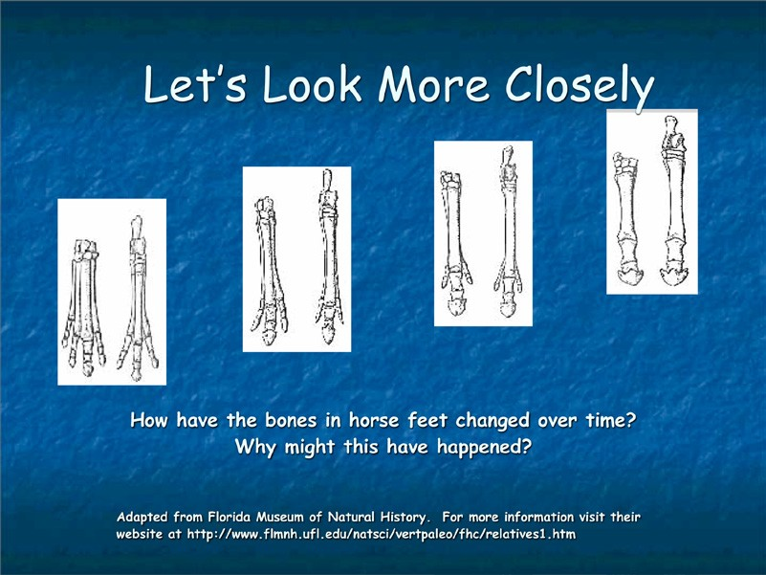
The bones become longer and more streamlined, enabling horses to run faster to avoid predators.

The central toe of horses became increasingly stronger while the “side toes”
became less important and are virtually lost in the modern horse.

Reduction and loss of side toes minimizes the weight at the extreme end of
the foot. The horse’s limb may move faster.

Changes:
• Middle bone (toe) becomes more dominant
• Side toes become virtually lost

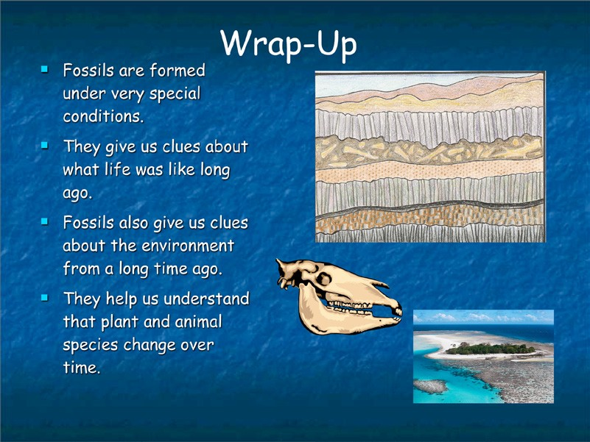

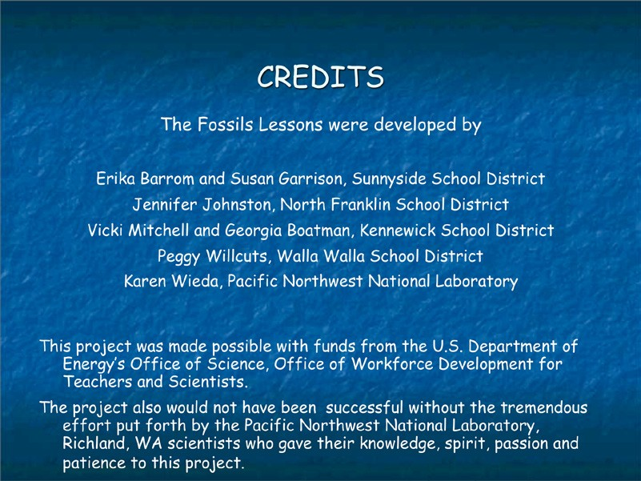

Analysis of Fossil Samples

Fossil | Plant | Animal | Extinct | Not  Extinct | Land Water
Ammonite
Brachiopod
Crinoid Stem
Dinosaur Bone
Dinosaur Egg Shell
Echinoid
Nautiloid
Oyster
Petrified Wood
Rugose Coral
Shark Tooth
Trilobite
* Students should use the text found on the Fossil Cards to cite evidence for extinct and not extinct.

Analysis of Fossil Samples

Fossil | Plant | Animal | Extinct | Not  Extinct | Land | Water
Ammonite
Brachiopod
Crinoid Stem
Dinosaur Bone
Dinosaur Egg Shell
Echinoid
Nautiloid
Oyster
Petrified Wood
Rugose Coral
Shark Tooth
Trilobite
* Students should use the text found on the Fossil Cards to cite evidence for extinct and not extinct.

 | Fossil Type |  | Status |  | Habitat
Fossil | Plant | Animal | Extinct | Not Extinct | Land | Water
Bryozoan
Brachiopod
Trilobite
Cephalopod – Nautiloid
Coral
Gastropod
Crinoid
Bivalve
Shark tooth
Sponge
*Students should be able to use booklet in fossil kit to get all of this information

 | Fossil Type |  | Status |  | Habitat
Fossil | Plant | Animal | Extinct | Not Extinct | Land | Water
Bryozoan
Brachiopod
Trilobite
Cephalopod – Nautiloid
Coral
Gastropod
Crinoid
Bivalve
Shark tooth
Sponge
*Students should be able to use booklet in fossil kit to get all of this information

